Proof of Concept (Web Portfolio)

Objective:
Create a responsive portfolio landing page with core functionalities including:
- Contact form(connects to a db)
- CV download
- Latest IT related news
Scope:
- Core features: Landing Page, Contact Form, Downloadable CV, IT news section and Connection to database
- Tech Stack: React, Tailwind CSS, News API, SupaBase
- Platform: Main use Desktop, Will later add mobile compatibility
Planning/Designs:
So for the last outcome of the website and layout of it, I chose to keep it minimalistic and simple. Sectioning out the website into parts and giving each main core functionality a section.
- Landing Page/CV Download
- About Section
- Latest News Section
- Contacts Section
Tech Stack/Tools:
- Visual Studio Code
- Node JS
- React JS, Tailwind
- API: NewsAPI
- SupaBase as DB
Deployment/Version Control Tools:
- Git/GitHub
- NPM
- React Testing

Timeline:
Phases:
Week 1: Planning, Setup & Creating Basic Structure of the work environment
Week 2: Component Creation & Resources installation (API & Database)
Week 3: API Integration & Database Integration
Week 4: Polishing Site, Testing & Adding Mobile Compatibility (if there is more time

Design:
Design Hierarchy:

Design plans were created using Figma:
Landing page/About section:
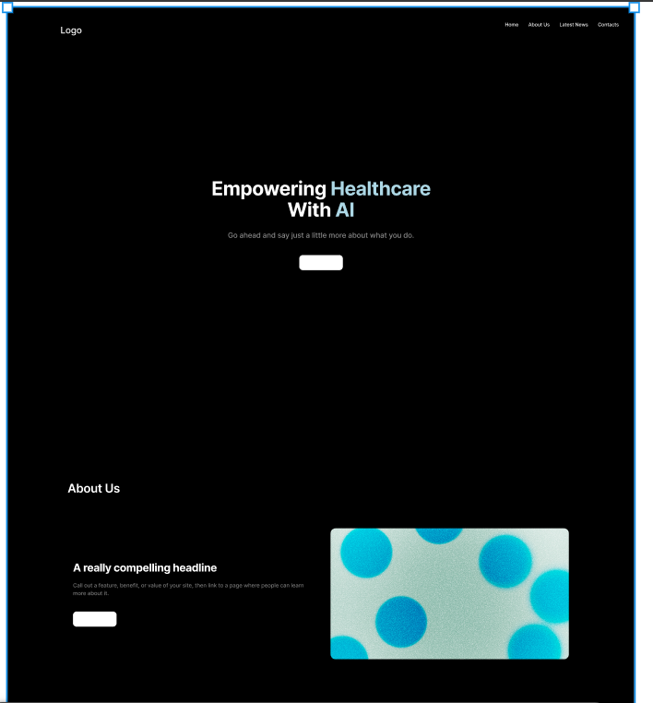

Latest News/Contact Section:
